Paper Title, Sentence case, Bold, & 12 Words or Less (17pt)
First Author^{1,*}, Second Author², Third Author³ (12pt) [minimal two author]
¹First affiliation, Address, City and Postcode, Country (10pt)
¹Email First Author*; ² Email Second Author; ³ Email Third Author (10pt)
*corresponding author
ABSTRACT
Abstract is a main description for readers on the whole article content. Abstract consists of the outline of all article components (objectives, methods, results, and conclusion). It includes 150-200 words, no reference citation, and written in one paragraph. The abstract should be written using Times New Roman-10pt in Bahasa Indonesia and English. It is complemented with 3-6 keywords. The keywords in the Bahasa Indonesia abstract should be written upright, while the English should be italic.
Keywords: first keyword, second keyword, third keyword
ARTICLE INFO
Article History: |  | Correspondence Address:
Accepted  Approved | :  : | Name of Correspondence Author  Department. Institution/University  Institution/University Address  E-mail: authorname@web.com
Available Online June 2026

INTRODUCTION (Microsoft Word template style: Heading 1)

The first part of article manuscript writing systematics in IJFaH Journal is introduction which consists of background descriptions, research urgency, and research objectives. Please display previous research to support research novelty. The articles sent to the IJFaH Journal are writings of research results in the field of Sports Science (Exercise Physiology & Adaptation, Physical Fitness Assessment, Strength & Conditioning Science, Physical Activity & Public Health, Training Interventions, Human Movement, Food, Nutrition, and Exercise Metabolism, Sports Medicine, and other fitnes and Health) that have never been published.

This IJFaH Journal manuscript template provides examples and guidelines for authors. To use this template, authors can copy and paste the document by using "Special Paste" and selecting "Unformatted Text". Please do not add headers, footers, or page numbers to this article template.

The manuscript should be written on A4 size paper, with 1 column format and 2.54 cm margins for top, bottom, left, and right. The writing in the manuscript should be written in 12pt Times New Roman, 1.5 spacing, 3pt space after heading and 6pt space before new heading. To format a paragraph, please use Microsoft Word with the template: Paragraph.

METHODS (Microsoft Word template style: Heading 1)

This method section includes the type of research, research subjects, data collection instruments, and data analysis. Aside from the title, the template provides a heading style for each title in the manuscript: heading 1, heading 2, and heading 3 (Use Microsoft Word template style: Heading 1). These headings are only guidelines and not the part of the manuscript title.

First Subhead of Methods (Microsoft Word template style: Heading 2)
This section contains subsections of Methods. Authors can use heading 2 style for the subhead and use this heading style for the subheads in other sections of this manuscript.

Sub of Subhead (Microsoft Word template style: Heading 3)
If the manuscript contains sub of subheads, authors can use heading 3 styleand use this heading style for sub of subheads in other parts of this manuscript.

Second Subhead of Methods (Microsoft Word template style: Heading 2)
This section contains other subsections of Methods. Authors can use heading 2 style for the subhead and use this heading style for the subheads in other sections of this manuscript.

RESULTS AND DISCUSSION (Microsoft Word template style: Heading 1)
This section contains research results or data, analysis of research data, answers of research questions, and analysis of findings during the research.

Results (Microsoft Word template style: Heading 2)
Authors can add tables and figures in manuscript. The rules of attaching tables and figures follow the APA 6th. An example of attaching tables and figures can be seen below:
Table 1. The Tables Number are in Bold, The Titles are not.
No. | Indication | Frequency | Percentage (%)
1 | Very positive | 19 | 47.5%
2 | Positive | 15 | 37.5%
3 | Neutral | 4 | 10%
4 | Negative | 1 | 2.5%
5 | Very Negative | 1 | 2.5%
Total |  | 40 | 100%

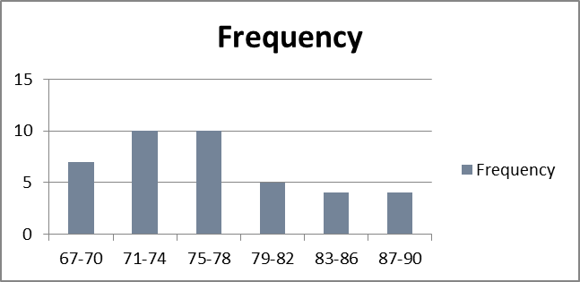

Figure 1. The Figures Number are in Bold, The Titles are not.

Discussion (Microsoft Word template style: Heading 2)
Discussion is the most important part of the entire scientific article content. The purpose of the discussion is to answer the research problem or show how the research objectives were achieved and interpret/analyze the results. The discussion begins by presenting the findings, then linking them with previous theory and research, whether the findings strengthen or otherwise rectify existing findings/theories. Emphasize new and important aspects. Discuss what was written in the results but do not repeat the results. Insert a discussion of the research impacts and limitations.

CONCLUSION (Microsoft Word template style: Heading 1)
This section contains the conclusion of research results related to research questions. This section also contains answers to research questions. Conclusion must answer specific objectives. This section is written in essay form and does not contain numbers. In the conclusion, suggestions can be written in the form of input for further researchs, as well as implicative recommendations from the research findings.

REFERENCES (Microsoft Word template style: Heading 1)
Books:
Freudenthal, H. (1991). Revisiting physical education. Dordrecht: Kluwer Academic Publishers.
Theses, Dissertations, Research Reports:
Zulkardi. (2002). Developing A Learning Environment on Realistic Physical Education for Indonesian Student Teachers. Published Dissertation. Enschede: University of Twente.
Symposiums, Proceedings, Conferences:
Prahmana, R.C.I. (2013). Designing Division Operation Learning in The Physical of Gasing. Proceeding in The First South East Asia Design/Development Research (SEA-DR) Conference 2013, 391-398. Palembang: Sriwijaya University
Articles in Journals:
Stacey, K. (2010). The view of physical education literacy in Indonesia. Journal on Physical Education, 2(2), 1-24. http://doi.org/Jv501.54545
Books Consist of Several Articles:
Russel, T. (1998). An Alternative Conception: Representing Representation. In P.J. Black & A. Lucas (Eds.), Children’s Informal Ideas in Science, 62-84. London: Routledge.

Internet:
Hitchcock, S., Carr, L., & Hall, W. (1996). A Survey of STM Online Journals, 1990-1995: The Calm before the Storm, (Online), (http://journal.ecs.soton.ac.uk/survey/survey.html), access 12 June 1996

Catatan :
Citations and references should use Mendeley or other reference manager softwares.
References should use APA 6th (American Psychological Association) Style.
Mandatory references are at least 20 references and 80% or (16 references) are scientific journals with DOI.

