The paper’s title should be the fewest possible words that accurately describe the content of the paper (Center, Bold, 14pt)

Khairil¹, Irma², Atssam³ (12 pt)
¹Department of Sport Science,Faculty of Sport and Health Science,Universitas Negeri Makassar, Makassar, Indonesia (10 pt)
²Department of Physical Education and Sports,Facultyof Teacher Training and Education, UniversitasMuhammadiyah Palopo, Palopo, Indonesia
³Department of Physical Education Health and Recreation,Faculty of Sport and Health Science, Universitas Negeri Makassar, Makassar, Indonesia
¹Email First Author*; ²Email Second Author; ³Email Third Author (10pt)
*corresponding author

Article Info |  | Abstract (10 pt)
Article history:  Received:  Revised:  Accepted: |  | An abstract is often presented separately from the article, so it must be able to stand alone. A well-prepared abstract enables the reader to quickly and accurately identify the basic content of a document, determine its relevance to their interests, and thus decide whether to read the document in its entirety. The abstract should be informative and completely self-explanatory, provide a clear statement of the problem, and the proposed approach or solution, and point out major findings and conclusions. The Abstract should not be more than 250 words in length. References should be avoided, but if essential, cite the author(s) and year(s). Standard nomenclature should be used, and non-standard or uncommon abbreviations should be avoided, but if essential they must be defined at their first mention in the abstract itself. No literature should be cited. The keyword list provides the opportunity to add 5 to 7 keywords, used by the indexing and abstracting services, in addition to those already present in the title (10 pt).
Keywords:
First keyword
Second keyword
Third keyword
Fourth keyword
Fifth keyword

Article type:
Review article/Research article
This work is licensed under a Creative Commons Attribution 4.0 International License (CC BY 4.0).


Corresponding author :
Name :
Affiliation :
Email :

1. Introduction
The introduction should include……
1.1. Background information
Start by introducing the broad topic area and provide relevant background information to give readers the necessary context. This helps them understand the significance of your research.
1.2. Research gap
Identify and highlight the gap in existing knowledge or the unanswered question that your study aims to address. Explain why this gap is important and how your research fills it.
1.3. Research objectives
There must be at least one research objective in this study.
1.4. Research questions
There must be at least one research question in this study.
1.5. Significance of the study
Discuss the importance and potential implications of your research. Explain how your findings could contribute to the field or address real-world problems.

2. Methodology
(Authors must follow the subtitles in this section for the research articles)
2.1.Research Design

2.2. Samples and Sampling Techniques

2.3. Instruments

2.4. Data Collection Procedures

2.5. Data analysis

3. Result
Figures and Tables
Use good-quality images and give a caption below the image.

Figure 1 (Bold). Title of the image (Book Antiqua, Font 12, Centered, Single-spaced)
(Source of image – Book Antiqua, Font 10, Centered, Single-spaced)

The caption for the table must be above the table.

Table 1 (Bold). Title of the table (Book Antiqua, Font 12, Centered, Single-spaced)
No. | Indication | Frequency | Percentage (%)
1 | Very positive | 19 | 47.5%
2 | Positive | 15 | 37.5%
3 | Neutral | 4 | 10%
4 | Negative | 1 | 2.5%
5 | Very Negative | 1 | 2.5%
Total |  | 40 | 100%

The caption for the chart must be above the chart.

Chart 1 (Bold). Title of the chart (Book Antiqua, Font 12, Centered, Single-spaced)
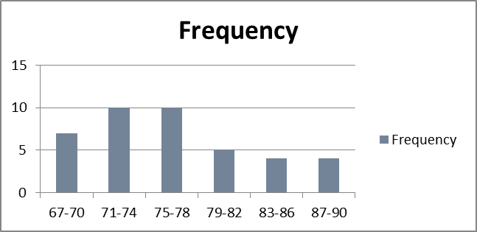

4. Discussion
Present logical analysis of findings of the study. Provide evidence to support your analysis by citing the work of previous studies or existing theories. [Explain whether your results agree or disagree with previous studies, and why].

5. Conclusion and recommendation
Clearly state how the objectives of the study are accomplished.

References
(APA Style 7th Edition)

